Josh Luka
CS320
9/26/2025
Lab 3
Lab 3: String Permutations

Before I continue, I have to check to make sure my food passes all my tests!
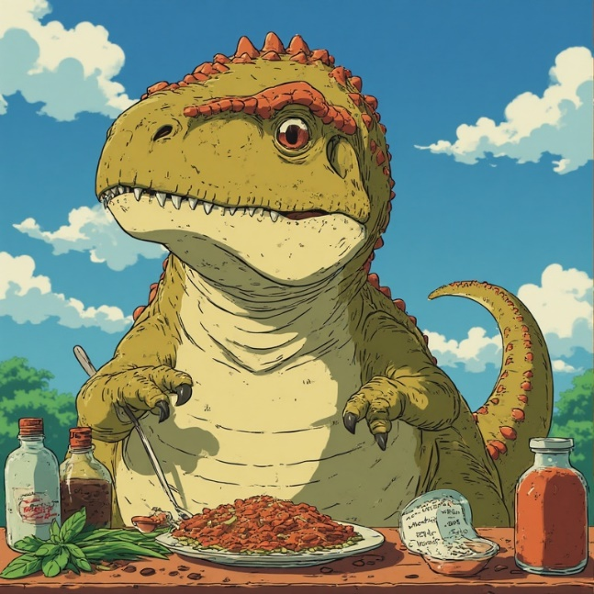
Now I have to check if my first meal has every ingredient on this list I was given

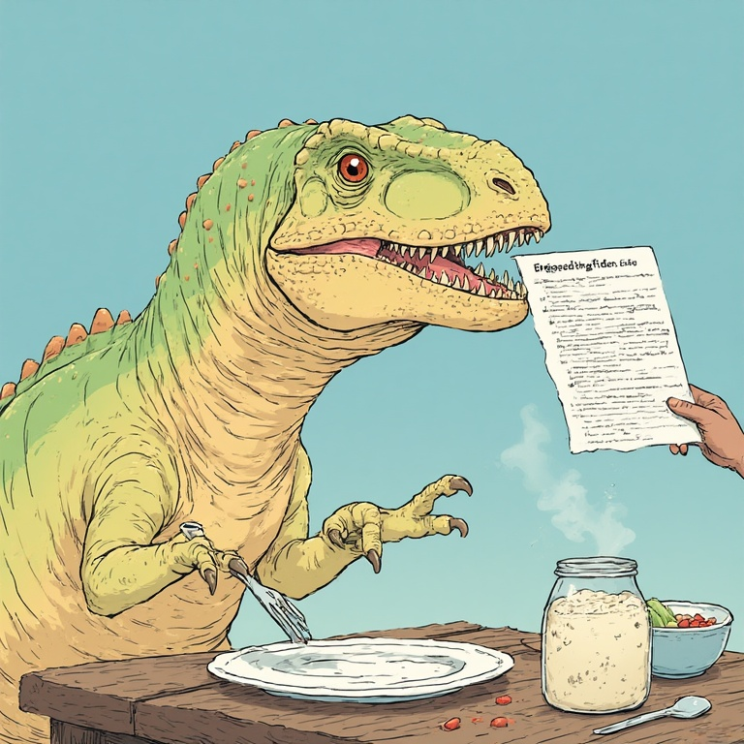
If my food does not include any the necessary ingredients
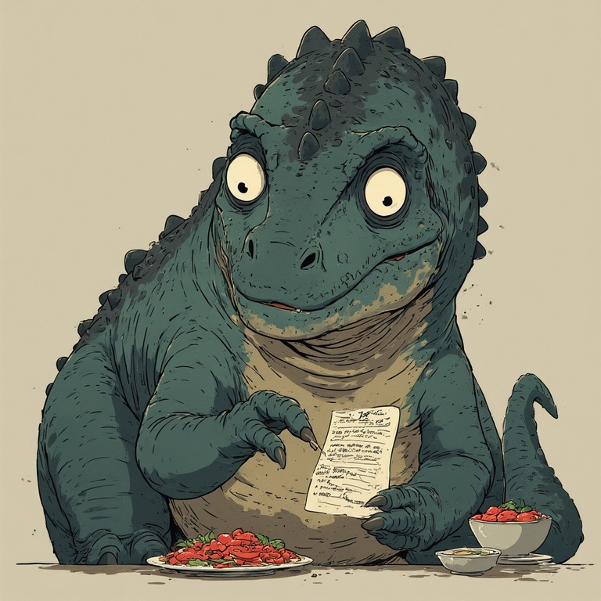
I have to move onto the next meal and check if it has the ingredients I need
while removing the bad ingredients


And another, different, meal since the last meal had every ingredient I needed.
I repeated this until all the meals were checked
I also removed the extra ingredients I already checked and didn’t match

Now I have, exclusively, all the meals that include the ingredients I need!!
Now I can invite the same amount of people I have meals!!

